(Approx. 1223 words)

NEWSLETTER EDITOR: If you choose to publish this article in an edition of your newsletter, then please send a PDF copy of that newsletter edition to the author at jkrout.patacs@gmail.com
Please do NOT publish the author's email address.

A Low-Battery Alarm App For Apple Portables
This app does not support full-battery alarms but does support multiple low-battery alarms. It allows you to assign a sound to each alarm and record your alert sound within the app.
By John Krout, Newsletter Contributor and Presenter
Potomac Area Technology and Computer Society
(www.patacs.org)

Introduction
In my January 20, 2024, presentation on Extending Your Battery Life, I focused on recharging when your portable device battery is in use and approaching complete depletion. During the discussion, an online visitor to our meeting mentioned that he prefers to recharge when the battery discharges to the 15% level. I knew that battery discharge to no lower than 15% to 20% would extend battery life, but I did not know how to arrange for a visible and audible alert to the device owner that a low power level had been reached.

Whatever you prefer, 15% or 20%, you can set the alarm for whenever your battery hits that low level while discharging, and for higher levels, too, using a free app on the App Store. The alarm will play its sound even if the app is not running when the battery discharges to that alarm level.

All of the screens shown here were captured from my iPhone X running iOS 16.7

The free app
It is unusual to recommend an app without reviews in the App Store. When I found it and decided to test it, it was relatively new to the store. The app's name is Don't Let Me Die! Its screens have a somewhat cartoonish feel.

Fortunately, the app offers a pretty simple user interface. I value simplicity. I do not care about the visual style so long as it does not make the functionality less obvious.

The app was buried deep in App Store search results, so I did not find it for quite a while. However, I can save you that search effort. At the end of this article, you will find a QR code that, when scanned by your portable camera, will give you the option to go directly to the app's App Store screen.

When first starting the app on your Apple device, the app displays the screen depicted in illustration 1. The app logs into your app account by providing your email address and the password you have chosen. If you have no account, tap Register now to begin the account creation process. I admit I am not sure this step is strictly required, but as a good follower, I did it.

When it starts, the app briefly displays a splash screen, and then the main screen appears, as shown in illustration 2.

The main screen is depicted after I configured two alarms to test. I tested whether or not those alarms would sound when the battery discharged to the alarm levels shown while the app was not running. Those two alarms did indeed sound while the app was not running.

The words associated with each alarm identify tone titles provided by the app and selected by the user, me, in this instance.

Creating a low-battery alarm
To create a new low-battery alarm, tap the + icon in the white circle at the bottom center of the main screen in illustration 2.

An alarm creation screen appears, like the one depicted in illustration 3. The Choose % portion includes a scrolling percentage scale. Scroll the scale up or down and then tap to select the percentage at which an alarm will sound while discharging.

Below that, you can select an alarm sound to be played. Tap Choose File to select either a tone provided by the app or any song or tone on your Apple portable.

When you tap Choose File, the popup shown in illustration 4 appears. In the popup, tap Add New to select any tone installed on your device. If you prefer, click below to add new, which is a scrolling list of short songs provided by the app. Scroll through the list and tap any title to audition it. Tap the red Select button if you want to use the tone you have heard as an audible alert.

I auditioned a couple of those app-provided songs. Most include vocals. I found the lyrics not easy to understand, though they are in English, and the audio volume appears too low for an alarm to be heard while the Apple portable is in a pocket or purse.

If you give up on the popup options, then swipe the popup down to remove it from the screen.

In the illustration 2 screen, tap Record Audio to use the device microphone to record a voice or any other nearby sound.

After creating or selecting a sound, tap the Submit button at the bottom of the screen in Illustration 2. The main screen reappears, showing the newly submitted alarm.

There is limited room on the main screen for listing alarms. If you create several, the list will appear to be scrollable so you can view all configured alarms.

Each alarm only sounds once. Because of that, I suggest using or creating a fairly long-duration audio tone.
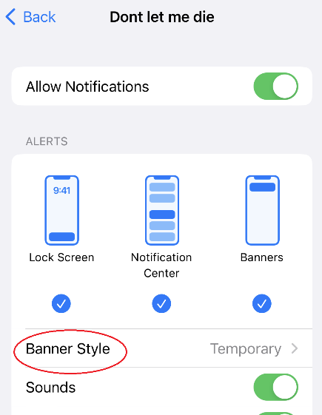
Also, each alarm presents a screen display, known in iOS as a banner. That banner is configured by default as Temporary, meaning it appears briefly and then vanishes so it can disappear before being seen. It may be more helpful to change that Banner style from Temporary to Persistent so that the banner will persist until the user consciously chooses to dismiss it.

Making the alarm banners Persistent
In Settings, there are two ways to reach the app settings screen: select Notifications or the app name, or the app name, and then Notifications.

Either way, you reach the screen shown in illustration 5.

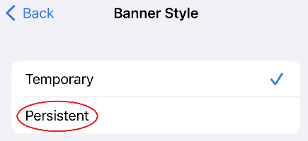
Tap the Banner Style heading, which is circled in the illustration.

That tap opens the straightforward Banner Style page shown in illustration 5. Tap the word Persistent, which is circled in the illustration.
illustration 61
illustration 51
You are done. You can close the Settings app.

Obtaining the app from the App Store
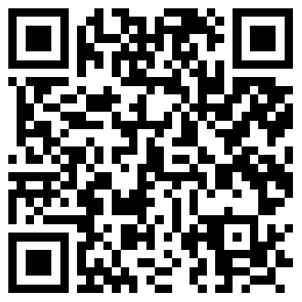
Here is the QR code for finding the Don't Let Me Die app in the App Store. If you have a recent model Apple Portable, then its camera app can scan QR codes.

If you focus the Camera app on the QR code, and no pop appears on your device screen, then you have to enable that QR code scanning capability in the Settings screen for the Camera app. On iOS 16.7 on my iPhone X, the Scan QR codes on/off switch are clearly labeled and very easy to see on the Camera settings screen.

ABOUT THE AUTHOR: John Krout is a retired software engineer. During his career, he did all the tasks related to software development, from requirements analysis to software documentation and training. He began writing about speaking about computer software in the early 1980s and now also covers smartphones, tablets, EVs, and PHEVs. He contributes to PATACS POSTS, the newsletter of the Potomac Area Technology and Computer Society. He provides educational presentations at meetings of that group and for APCUG Wednesday Workshops.

